Aldona Sopata
prof. UAM dr hab.

Faculty of Modern Languages and Literatures
Department of Studies on Multilingualism,
Institute of Applied Linguistics

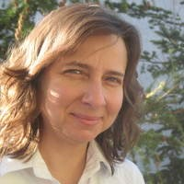

Selected Publications:
- Brehmer, Bernhard, and Aldona Sopata. 2021. Word Order in Complex Verb Phrases in Heritage Polish Spoken in Germany. Languages 6: 70.
https://www.mdpi.com/2226-471X/6/2/70
- Sopata Aldona, Długosz Kamil, Brehmer Bernhard, Gielge Raina, 2021, Cross-linguistic influence in simultaneous and early sequential acquisition: Null subjects and null objects in Polish-German bilingualism, International Journal of Bilingualism, 1-21. DOI:10.1177/1367006920988911
- Sopata Aldona, 2019, Cross-linguistic influence in the development of null arguments in early successive bilingual acquisition. Linguistic Approaches to Bilingualism, https://doi.org/10.1075/lab.18016.sop

Scientific interests:
Prof. Aldona Sopata has been exploring linguistic issues related to language development in various contexts, i.e. first language acquisition, bilingual language acquisition, second language acquisition, child successive language acquisition, foreign language acquisition in school settings (young and adult learners). Her research interests include simultaneous and early sequential bilingualism, heritage languages, family language policy, acquisition of syntax and phenomena at the interface between syntax and other cognitive domains.

