Anna Ewert
prof. UAM dr hab.

Faculty of English
Department of Applied English Linguistics and Language Teaching

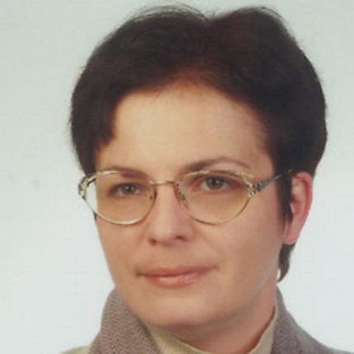

Representative publications:
- Ewert A. 2016. “Space, motion and thinking for language.” In: Cook, Vivian; Li Wei (eds.) The Cambridge Handbook of Linguistic Multi-Competence. Cambridge: Cambridge University Press, 376-402.
- Tomczak E, Ewert A. 2015. Real and fictive motion processing in Polish L2 users of English and monolinguals: Evidence for different conceptual representations. Modern Language Journal 99(S1): 49-65.
- Ewert A, Czechowska N. 2011. “Perception of motion by Polish-English bilinguals.” In: Cook, V.; Bassetti, B. (eds.) Language and Bilingual Cognition. New York/Hove: Psychology Press, 287-314.

Areas of interest:
bilingualism, language and cognition; crosslinguistic differences in linguistic categorization and conceptual categories; cognitive processing in bilinguals

More information:
http://wa.amu.edu.pl/wa/ewert_anna

