Radosław Piętka
prof. UAM dr hab.

Faculty of Polish and Classical Philology
Institute of Classical Philology
Department of Latin Studies

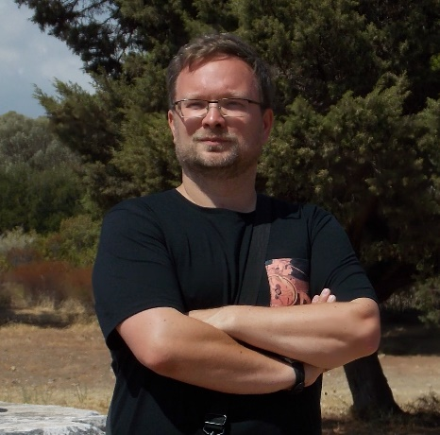

Selected publications:
- „Trina tempestas” (Carmina Einsidlensia 2.33). „Harvard Studies in Classical Philology” 2010, vol. 105, s. 177-187
- Roma aeterna. Rzymska mitologia urbanistyczna. Poznań 2015 [Roma aeterna: The Urbanistic Mythology of Rome]
- A Thrill for Latinists. Latin Language in Contemporary Horror Films. In: Antiquity in Popular Literature and Culture. Ed. K. Dominas. Newcastle upon Tyne 2016, s. 255-266
- Catullus 64: The Game of the Names. „Eos” 2019, vol. XC, fasc. 1, s. 23-29

Radosław Piętka is University Professor of Classics at Adam Mickiewicz University in Poznań, Poland. He is the author of over sixty articles, book chapters, reviews, translations etc. His research focuses mainly on Menippean literature, Roman astronomical poetry, Roman religion and mythology, and influence of antiquity on modern culture (especially on films). Currently he is working on the Polish translation of one of the Latin works by Swedish mystic Emanuel Swedenborg.

More information:
https://ifk.amu.edu.pl/ifk/ifk/pracownicy?a=103861

